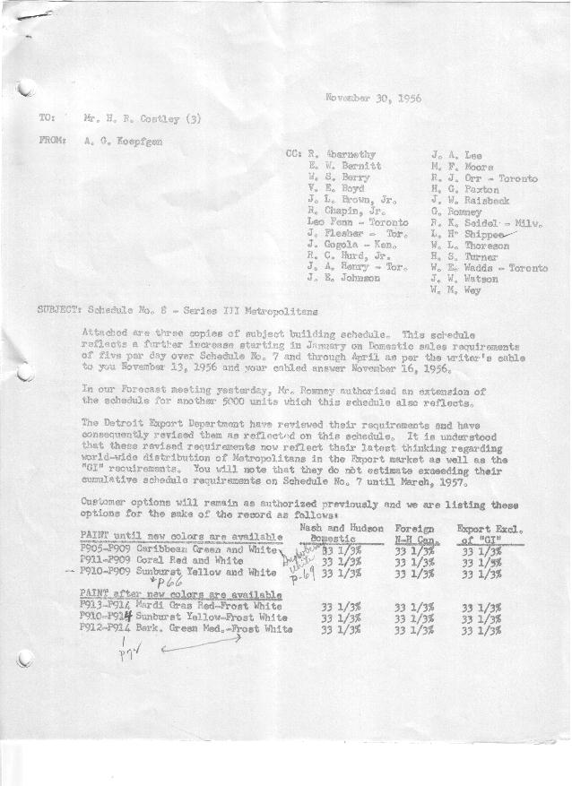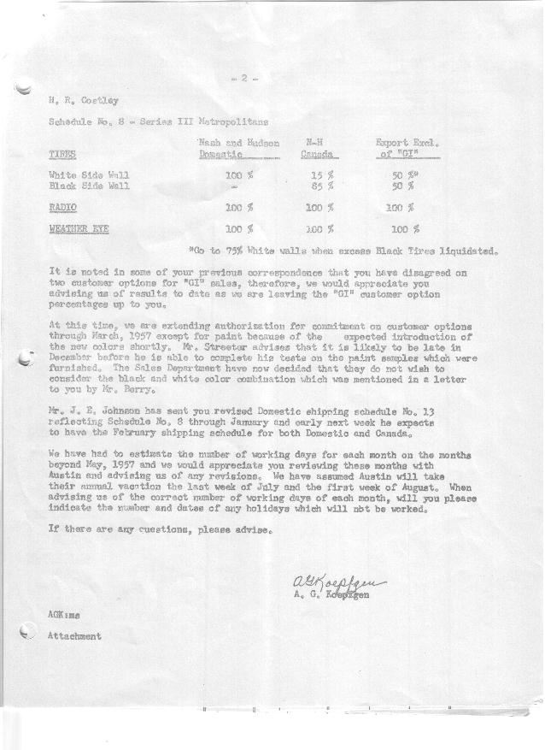

FORM PLAN 68 REV. 2-55-A.M.P Page 1 of 2 APPROVED Unknown (signed) DATE 11/30/56 APPROVED R. Abernethy (signed) DATE_ 12 / 3 /56 ____

SCHEDULE NO. ______8 ___ DATE 11 /30 /56 MONTHLY BUILDING SCHEDULE APPROVED R.J. Orr (printed) DATE_per letter of 11-29 _
REVISION NO. _______ _______ DATE PRODUCT APPROVED E.W. Bernitt (signed) ___ _DATE _ 12 /3/ 56 ____
SERIES III 1500 c.c. ENGINE
METROPOLITAN SERIES CARS – AUSTIN MTRS. CO., LTD, ENGLAND
DESCRIPTION | BUILT  ◻ACT EST  THRU  November | FIRM BUILDING SCHEDULE  (FABRICATED MATERIAL RELEASE) |  |  |  |  |  |  |  |  |  |  |  |  |  |  | TENTATIVE SCHEDULE  (RAW MATERIAL RELEASED) |  |  | GRAND  TOTAL
DESCRIPTION | BUILT  ◻ACT EST  THRU  November | MONTH Dec.  DAYS 18 |  |  | MONTH Jan.  DAYS 22 |  |  | MONTH Feb.  DAYS 20 |  |  | MONTH March  DAYS 21 |  |  | MONTH April  DAYS 20 |  |  |  |  |  | GRAND  TOTAL
DESCRIPTION | BUILT  ◻ACT EST  THRU  November | DAILY | MONTH | CUM’L  TOTAL | DAILY | MONTH | CUM’L  TOTAL | DAILY | MONTH | CUM’L  TOTAL | DAILY | MONTH | CUM’L  TOTAL | DAILY | MONTH | CUM’L  TOTAL | DAILY | MONTH | CUM’L TOTAL | GRAND  TOTAL
DOMESTIC:
Hard-Top | 6061 |  | 595 | 6656 |  | 863 | 7519 |  | 814 | 8333 |  | 858 | 9191 |  | 814 | 10005
Soft-Top | 717 |  | 78 | 795 |  | 82 | 877 |  | 130 | 1007 |  | 133 | 1140 |  | 130 | 1270
Total U.S. | 6778 | 37.4 | 673 | 7451 | 43.0 | 945 | 8396 | 47.2 | 944 | 9340 | 47.2 | 991 | 10331 | 47.2 | 944 | 11275
Over/(Under) Sched. No.7 | 0 |  | 0 | 0 |  | 110 | 110 |  | 100 | 210 |  |  | 315 |  | 100 | 415
FOREIGN:
EXPORT Hard-Top | 408 |  | 35 | 443 |  | 60 | 503 |  | 70 | 573 |  | 105 | 678 |  | 106 | 784
Soft-Top | 190 |  | 5 | 195 |  | 25 | 220 |  | 25 | 245 |  | 55 | 300 |  | 54 | 354
Total Export | 598 |  | 40 | 638 |  | 85 | 723 |  | 95 | 818 |  | 160 | 978 |  | 160 | 1138
Over/(Under) Sched. No.7 | (108) |  | (10) | (118) |  | 54 | (64) |  | 34 | (30) |  | 96 | 66 |  | 99 | 165
CANADA NASH Hard-Top | 537 |  | 28 | 565 |  | 25 | 590 |  | 149 | 739 |  | 130 | 869 |  | 141 | 1010
Soft-Top | 15 |  | 0 | 15 |  | 15 | 30 |  | 6 | 36 |  | 33 | 69 |  | 14 | 83
Total Nash-Canada | 552 |  | 28 | 580 |  | 40 | 620 |  | 155 | 775 |  | 163 | 938 |  | 155 | 1093
Over/(Under) Sched. No.7 | 0 |  | 0 | 0 |  | 0 | 0 |  | 0 | 0 |  | 0 | 0 |  | 0 | 0
CANADA HUDSON Hard Top | 238 |  | 5 | 243 |  | 15 | 258 |  | 90 | 348 |  | 65 | 413 |  | 45 | 458
Soft Top | 10 |  | 0 | 10 |  | 3 | 13 |  | 10 | 23 |  | 10 | 33 |  | 5 | 38
Total Hudson Canada | 248 |  | 5 | 253 |  | 18 | 271 |  | 100 | 371 |  | 75 | 446 |  | 50 | 496
Over/(Under) Sched. No.7 | 0 |  | 0 | 0 |  | 0 | 0 |  | 0 | 0 |  | (30) | (30) |  | (50) | (80)
TOTAL FOREIGN | 1398 | 4.0 | 73 | 1471 | 6.5 | 143 | 1614 | 17.5 | 350 | 1964 | 19.0 | 398 | 2362 | 18.2 | 365 | 2727
Over/(Under) Sched. No.7 | (108) |  | (10) | (118) |  | 54 | (64) |  | 34 | (30) |  | 66 | 36 |  | 49 | 85
GRAND TOTALS
Hard-Top | 7244 |  | 663 | 7907 |  | 963 | 8870 |  | 1123 | 9993 |  | 1158 | 11151 |  | 1106 | 12257
Soft-Top | 932 |  | 83 | 1015 |  | 125 | 1140 |  | 171 | 1311 |  | 231 | 1542 |  | 203 | 1745
Total | 8176 | 41.4 | 746 | 8922 | 49.5 | 1088 | 10010 | 64.7 | 1294 | 11304 | 66.2 | 1389 | 12693 | 65.4 | 1309 | 14002
Over/(Under) Sched. No.7 | (108) |  | (10) | (118) |  | 164 | 46 |  | 134 | 180 |  | 171 | 351 |  | 149 | 500

FORM PLAN 68 REV. 2-55-A.M.P Page 2 of 2 APPROVED Unknown (signed) DATE 11/30/56 APPROVED R. Abernethy (signed) DATE_ 12 / 3 /56 ____

SCHEDULE NO. ______8 ___ DATE 11 /30 /56 MONTHLY BUILDING SCHEDULE APPROVED R.J. Orr (printed) DATE_per letter of 11-29 _
REVISION NO. _______ _______ DATE PRODUCT APPROVED E.W. Bernitt (signed) ___ _DATE _ 12 /3/ 56 ____
SERIES III 1500 c.c. ENGINE
METROPOLITAN SERIES CARS – AUSTIN MTRS. CO., LTD, ENGLAND
DESCRIPTION | BUILT  ◻ACT◻ EST  THRU | FIRM BUILDING SCHEDULE  (FABRICATED MATERIAL RELEASE) |  |  |  |  |  |  |  |  |  |  |  |  |  |  | TENTATIVE SCHEDULE  (RAW MATERIAL RELEASED) |  |  | GRAND  TOTAL
DESCRIPTION | BUILT  ◻ACT◻ EST  THRU | MONTH May  DAYS 21 |  |  | MONTH June  DAYS 20 |  |  | MONTH July  DAYS 16 |  |  | MONTH Aug.  DAYS 15 |  |  | MONTH Sept.  DAYS 21 |  |  | MONTH Oct.  DAYS 19 |  |  | GRAND  TOTAL
DESCRIPTION | BUILT  ◻ACT◻ EST  THRU | DAILY | MONTH | CUM’L  TOTAL | DAILY | MONTH | CUM’L  TOTAL | DAILY | MONTH | CUM’L  TOTAL | DAILY | MONTH | CUM’L  TOTAL | DAILY | MONTH | CUM’L  TOTAL | DAILY | MONTH | CUM’L TOTAL | GRAND  TOTAL
DOMESTIC:
Hard-Top |  |  | 866 | 10871 |  | 819 | 11690 |  | 637 | 12327 |  | 500 | 12827 |  | 740 | 13567 |  | 648 | 14215
Soft-Top |  |  | 125 | 1395 |  | 125 | 1520 |  | 115 | 1635 |  | 100 | 1735 |  | 100 | 1835 |  | 88 | 1923
Total U.S. |  | 47.2 | 991 | 12266 | 47.2 | 944 | 13210 | 47. | 752 | 13962 | 40 | 600 | 14562 | 40 | 840 | 15402 | 40.0 | 736 | 16138
Over/(Under) Sched. No.7 |  |  | 105 | 520 |  | 705 | 1225 |  | 752 | 1977 |  | 600 | 2577 |  | 840 | 3417 |  | 736 | 4153
FOREIGN:
EXPORT Hard-Top |  |  | 100 | 884 |  | 85 | 969 |  | 65 | 1034 |  | 60 | 1094 |  | 60 | 1154 |  | 53 | 1207
Soft-Top |  |  | 45 | 399 |  | 35 | 434 |  | 30 | 464 |  | 25 | 489 |  | 23 | 512 |  | 20 | 532
Total Export |  |  | 145 | 1283 |  | 120 | 1403 |  | 95 | 1498 |  | 85 | 1583 |  | 83 | 1666 |  | 73 | 1739
Over/(Under) Sched. No.7 |  |  | 81 | 246 |  | 107 | 353 |  | 95 | 448 |  | 85 | 533 |  | 83 | 616 |  | 73 | 689
CANADA NASH Hard-Top |  |  | 82 | 1092 |  | 50 | 1142 |  | 40 | 1182 |  | 40 | 1222 |  | 70 | 1292 |  | 61 | 1353
Soft-Top |  |  | 10 | 93 |  | 0 | 93 |  | 0 | 93 |  | 0 | 93 |  | 0 | 93 |  | 0 | 93
Total Nash-Canada |  |  | 92 | 1185 |  | 50 | 1235 |  | 40 | 1275 |  | 40 | 1315 |  | 70 | 1385 |  | 61 | 1446
Over/(Under) Sched. No.7 |  |  | (72) | (72) |  | 36 | (36) |  | 40 | 4 |  | 40 | 44 |  | 70 | 114 |  | 61 | 175
CANADA HUDSON Hard Top |  |  | 48 | 506 |  | 25 | 531 |  | 20 | 551 |  | 20 | 571 |  | 35 | 606 |  | 31 | 637
Soft Top |  |  | 2 | 40 |  | 0 | 40 |  | 0 | 40 |  | 0 | 40 |  | 0 | 40 |  | 0 | 40
Total Hudson Canada |  |  | 50 | 546 |  | 25 | 571 |  | 20 | 591 |  | 20 | 611 |  | 35 | 646 |  | 31 | 677
Over/(Under) Sched. No.7 |  |  | (54) | (134) |  | 11 | (123) |  | 20 | (103) |  | 20 | (83) |  | 35 | (48) |  | 31 | (17)
TOTAL FOREIGN |  | 13.7 | 287 | 3014 | 9.8 | 195 | 3209 | 9.7 | 155 | 3364 | 9.7 | 145 | 3509 | 9.0 | 188 | 3697 | 9.0 | 165 | 3862
Over/(Under) Sched. No.7 |  |  | (45) | 40 |  | 154 | 194 |  | 155 | 349 |  | 145 | 494 |  | 188 | 682 |  | 165 | 847
GRAND TOTALS
Hard-Top |  |  | 1096 | 13353 |  | 979 | 14332 |  | 762 | 15094 |  | 620 | 15714 |  | 905 | 16619 |  | 793 | 17412
Soft-Top |  |  | 182 | 1927 |  | 160 | 2087 |  | 145 | 2232 |  | 125 | 2357 |  | 123 | 2480 |  | 108 | 2588
Total |  | 60.9 | 1278 | 15280 | 57.0 | 1139 | 16419 | 56.7 | 907 | 17326 | 49.7 | 745 | 18071 | 49.0 | 1028 | 19099 | 49.0 | 901 | 20000
Over/(Under) Sched. No.7 |  |  | 60 | 560 |  | 859 | 1419 |  | 907 | 2326 |  | 745 | 3071 |  | 1028 | 4099 |  | 901 | 5000

